Design patterns

Recurring solutions to common problems in software design.

Creational patterns
These patterns have to do with class instantiation. They can be further divided into class-creation patterns and object-creational patterns. While class-creation patterns use inheritance effectively in the instantiation process, object-creation patterns use delegation to get the job done.
- Abstract Factory groups object factories that have a common theme.
- Builder constructs complex objects by separating construction and representation.
- Factory Method creates objects without specifying the exact object to create.
- Prototype creates objects by cloning an existing object.
- Singleton restricts object creation for a class to only one instance.

Structural patterns
These concern Class and Object composition. They use inheritance to compose interfaces and define ways to compose objects to obtain new functionality.
- Adapter allows classes with incompatible interfaces to work together by wrapping its own interface around that of an already existing class.
- Bridge decouples an abstraction from its implementation so that the two can vary independently.
- Composite composes one-or-more similar objects so that they can be manipulated as one object.
- Decorator dynamically adds/overrides behaviour in an existing method of an object.
- Facade provides a simplified interface to a large body of code.
- Flyweight reduces the cost of creating and manipulating a large number of similar objects.
- Proxy provides a placeholder for another object to control access, reduce cost, and reduce complexity.

Behavioral patterns
These design patterns are about Class's objects communication. They are specifically concerned with communication between objects.
- Chain of responsibility delegates commands to a chain of processing objects.
- Command creates objects which encapsulate actions and parameters.
- Interpreter implements a specialized language.
- Iterator accesses the elements of an object sequentially without exposing its underlying representation.
- Mediator allows loose coupling between classes by being the only class that has detailed knowledge of their methods.
- Memento provides the ability to restore an object to its previous state (undo).
- Observer is a publish/subscribe pattern which allows a number of observer objects to see an event.
- State allows an object to alter its behavior when its internal state changes.
- Strategy allows one of a family of algorithms to be selected on-the-fly at runtime.
- Template method defines the skeleton of an algorithm as an abstract class, allowing its subclasses to provide concrete behavior.
- Visitor separates an algorithm from an object structure by moving the hierarchy of methods into one object.
scope/Purpose | Creational | Structural | Behavioral
Class | Factory Method | Adapter | Interpreter
Class |  |  | Template Method
Object | Abstract Factory | Adapter | Chain of Responsibility
Object | Factory | Bridge | Command
Object | Builder | Composite | Iterator
Object | Prototype | Decorator | Mediator
Object | Singleton | Facade | Memento
Object |  | Flyweight | Observer
Object |  | Proxy | State
Object |  |  | Strategy
Object |  |  | Visitor

Creational Patterns

Factory Pattern
Consider as an example a program to read image files and make thumbnails out of them. The program supports different image formats, represented by a reader class for each format:
public interface ImageReader {
public DecodedImage getDecodedImage();
}

public class GifReader implements ImageReader {
public GifReader( InputStream in ) {
// check that it's a gif, throw exception if it's not, then if it is
// decode it.
}

public DecodedImage getDecodedImage() {
return decodedImage;
}
}

public class JpegReader implements ImageReader {
//....
}

Each time the program reads an image it needs to create a reader of the appropriate type based on some information in the file. This logic can be encapsulated in a factory method:
public class ImageReaderFactory {
public static ImageReader getImageReader( InputStream is ) {
int imageType = figureOutImageType( is );

switch( imageType ) {
case ImageReaderFactory.GIF:
return new GifReader( is );
case ImageReaderFactory.JPEG:
return new JpegReader( is );
// etc.
}
}
}

Abstract Factory Pattern
This insulates client code from object creation by having clients ask a factory object to create an object of the desired abstract type and to return an abstract pointer to the object

The class diagram of this design pattern is as shown below:
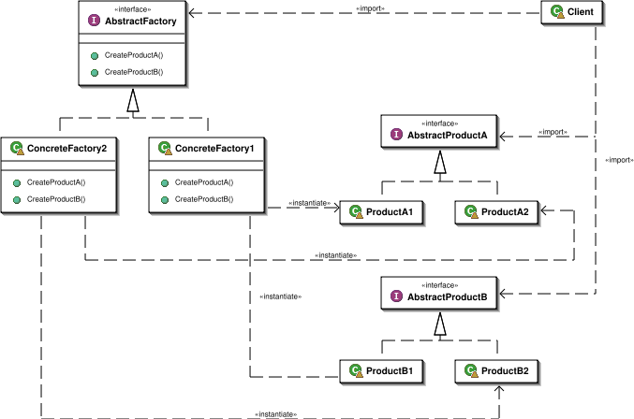

Examples
/*
* GUIFactory example
*/
abstract class GUIFactory
{
public static GUIFactory getFactory()
{
int sys = readFromConfigFile("OS_TYPE");
if (sys == 0)
{
return new WinFactory();
}
else
{
return new OSXFactory();
}
}

public abstract Button createButton();
}

class WinFactory extends GUIFactory
{
public Button createButton()
{
return new WinButton();
}
}

class OSXFactory extends GUIFactory
{
public Button createButton()
{
return new OSXButton();
}
}

abstract class Button
{
public abstract void paint();
}

class WinButton extends Button
{
public void paint()
{
System.out.println("I'm a WinButton: ");
}
}

class OSXButton extends Button
{
public void paint()
{
System.out.println("I'm an OSXButton: ");
}
}

public class Application
{
public static void main(String[] args)
{
GUIFactory factory = GUIFactory.getFactory();
Button button = factory.createButton();
button.paint();
}
// Output is either:
// "I'm a WinButton:"
// or:
// "I'm an OSXButton:"
}

Builder Pattern
The intention is to separate the construction of a complex object from its representation so that the same construction process can create different representations.

Class Diagram
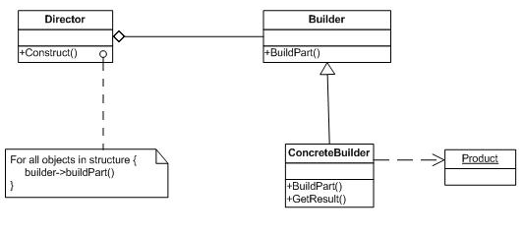
Prototype Pattern
The Prototype pattern is used when creating an instance of a class is very time-consuming or complex in some way. Then, rather than creating more instances, you make copies of the original instance, modifying them as appropriate. Prototypes can also be used whenever you need classes that differ only in the type of processing they offer i.e. when there are many subclasses that differ only in the kind of objects they create a Prototype Pattern can be used to reduce the number of subclasses by cloning a prototype.

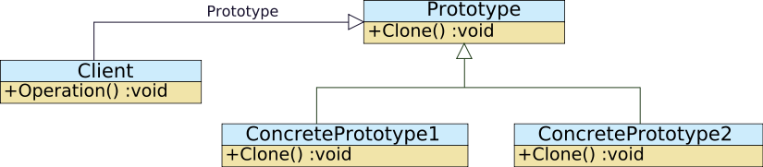

Singleton Pattern
The singleton pattern is a design pattern that is used to restrict instantiation of a class to one object. This is useful when exactly one object is needed to coordinate actions across the system

Object Pool Pattern

object pool is a set of initialised objects that are kept ready to use, rather than allocated and destroyed on demand. A client of the pool will request an object from the pool and perform operations on the returned object. When the client has finished with an object, it returns it to the pool, rather than destroying it. It is a specific type of factory object.

Structural Patterns
Structural patterns describe how classes and objects can be combined to form larger structures. The difference between class patterns and object patterns is that class patterns describe how inheritance can be used to provide more useful program interfaces. Object patterns, on the other hand, describe how objects can be composed into larger structures using object composition, or the inclusion of objects within other objects

Adapter Pattern
We use adapters whenever we want unrelated classes to work together in a single program. The concept of an adapter is thus pretty simple; we write a class that has the desired interface and then make it communicate with the class that has a different interface.

There are two types of adapter patterns:
- The Object Adapter pattern - In this type of adapter pattern, the adapter contains an instance of the class it wraps. In this situation, the adapter makes calls to the instance of the wrapped object.
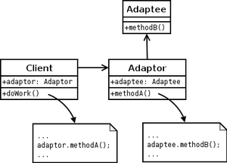
The object adapter pattern expressed in UML. The adapter hides the adaptee's interface from the client.
- The Class Adapter pattern - This type of adapter uses multiple inheritance to achieve its goal. The adapter is created inheriting interfaces from both the interface that is expected and the interface that is pre-existing. Note that when the adapter must adapt multiple adaptees, the Class Adapter pattern cannot be used in languages such as Java that do not support multiple inheritance.
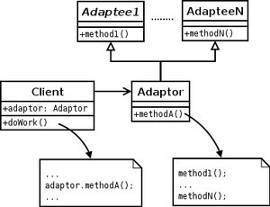
The class adapter pattern expressed in UML.
The adapter pattern is useful in situations where an already existing class provides some or all of the services you need but does not use the interface you need. A good real life example is an adapter that converts the interface of a Document Object Model of an XML document into a tree structure that can be displayed. A link to a tutorial that uses the adapter design pattern is listed in the links below.

Sample - Class Adapter
/**
* Java code sample
*/

interface Stack
{
void push (Object o);
Object pop ();
Object top ();
}

/* DoubleLinkedList */
class DList
{
public void insert (DNode pos, Object o) { ... }
public void remove (DNode pos) { ... }

public void insertHead (Object o) { ... }
public void insertTail (Object o) { ... }

public Object removeHead () { ... }
public Object removeTail () { ... }

public Object getHead () { ... }
public Object getTail () { ... }
}

/* Adapt DList class to Stack interface */
class DListImpStack extends DList implements Stack
{
public void push (Object o) {
insertTail (o);
}

public Object pop () {
return removeTail ();
}

public Object top () {
return getTail ();
}
}

Composite Pattern
Composite allows a group of objects to be treated in the same way as a single instance of an object.
When dealing with tree-structured data, programmers often have to discriminate between a leaf-node and a branch. This makes code more complex, and therefore, error prone.

Structure
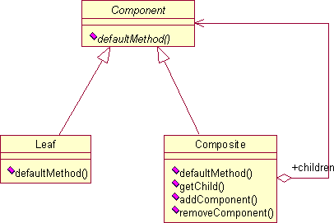
Component
- is the abstraction for all components, including composite ones
- declares the interface for objects in the composition
- implements default behavior for the interface common to all classes, as appropriate
- declares an interface for accessing and managing its child components
- (optional) defines an interface for accessing a components's parent in the recursive structure, and implements it if that's appropriate
Leaf
- represents leaf objects in the composition
- implements all Component methods
Composite
- represents a composite Component (component having children)
- implements methods to manipulate children
- implements all Component methods, generally by delegating them to its children

Example
The following example, written in Java, implements a graphic class, which can be either an ellipse or a composition of several graphics. Every graphic can be printed.
It could be extended to implement several other shapes (rectangle etc.) and methods (translate etc.).
import java.util.ArrayList;

interface Graphic {

//Prints the graphic.
public void Print();

}

class CompositeGraphic implements Graphic {

//Collection of child graphics.
private ArrayList<Graphic> mChildGraphics = new ArrayList<Graphic>();

//Prints the graphic.
public void Print() {
for (Graphic graphic : mChildGraphics) {
graphic.Print();
}
}

//Adds the graphic to the composition.
public void Add(Graphic graphic) {
mChildGraphics.add(graphic);
}

//Removes the graphic from the composition.
public void Remove(Graphic graphic) {
mChildGraphics.remove(graphic);
}

}

class Ellipse implements Graphic {

//Prints the graphic.
public void Print() {
System.out.println("Ellipse");
}

}

public class Program {

public static void main(String[] args) {
//Initialize four ellipses
Ellipse ellipse1 = new Ellipse();
Ellipse ellipse2 = new Ellipse();
Ellipse ellipse3 = new Ellipse();
Ellipse ellipse4 = new Ellipse();

//Initialize three composite graphics
CompositeGraphic graphic = new CompositeGraphic();
CompositeGraphic graphic1 = new CompositeGraphic();
CompositeGraphic graphic2 = new CompositeGraphic();

//Composes the graphics
graphic1.Add(ellipse1);
graphic1.Add(ellipse2);
graphic1.Add(ellipse3);

graphic2.Add(ellipse4);

graphic.Add(graphic1);
graphic.Add(graphic2);

//Prints the complete graphic (four times the string "Ellipse").
graphic.Print();
}
}

Bridge Pattern
Decouple an abstraction from its implementation so that the two can vary independently" (Gamma et al.). The bridge uses encapsulation, aggregation, and can use inheritance to separate responsibilities into different classes.

Structure

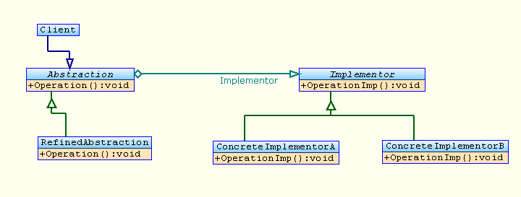
Ex:
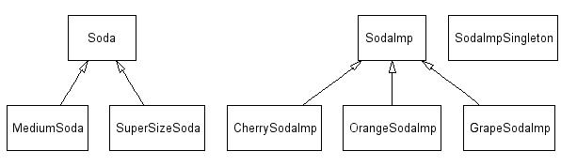

Soda.java - the Abstract Base Class
public abstract class Soda {
SodaImp sodaImp;

public void setSodaImp() {
this.sodaImp = SodaImpSingleton.getTheSodaImp();
}
public SodaImp getSodaImp() {
return this.sodaImp;
}

public abstract void pourSoda();
}

MediumSoda.java - one of two classes extending the Abstract
public class MediumSoda extends Soda {
public MediumSoda() {
setSodaImp();
}

public void pourSoda() {
SodaImp sodaImp = this.getSodaImp();
for (int i = 0; i < 2; i++) {
System.out.print("...glug...");
sodaImp.pourSodaImp();
}
System.out.println(" ");
}
}

SuperSizeSoda.java - two of two classes extending the Abstract
public class SuperSizeSoda extends Soda {
public SuperSizeSoda() {
setSodaImp();
}

public void pourSoda() {
SodaImp sodaImp = this.getSodaImp();
for (int i = 0; i < 5; i++) {
System.out.print("...glug...");
sodaImp.pourSodaImp();
}
System.out.println(" ");
}
}

SodaImp.java - the Implementation Base Class
public abstract class SodaImp {
public abstract void pourSodaImp();
}

CherrySodaImp.java - one of three classes extending the Implementation Base Class
public class CherrySodaImp extends SodaImp {
CherrySodaImp() {}

public void pourSodaImp() {
System.out.println("Yummy Cherry Soda!");
}
}

GrapeSodaImp.java - two of three classes extending the Implementation Base Class
public class GrapeSodaImp extends SodaImp {
GrapeSodaImp() {}

public void pourSodaImp() {
System.out.println("Delicious Grape Soda!");
}
}

OrangeSodaImp.java - three of three classes extending the Implementation Base Class
public class OrangeSodaImp extends SodaImp {
OrangeSodaImp() {}

public void pourSodaImp() {
System.out.println("Citrusy Orange Soda!");
}
}

SodaImpSingleton.java - a Singleton to hold the current SodaImp
public class SodaImpSingleton {
private static SodaImp sodaImp;

public SodaImpSingleton(SodaImp sodaImpIn) {
this.sodaImp = sodaImpIn;
}

public static SodaImp getTheSodaImp() {
return sodaImp;
}
}

TestBridge.java - testing the Bridge
class TestBridge {
public static void testCherryPlatform() {
SodaImpSingleton sodaImpSingleton =
new SodaImpSingleton(new CherrySodaImp());
System.out.println(
"testing medium soda on the cherry platform");
MediumSoda mediumSoda = new MediumSoda();
mediumSoda.pourSoda();
System.out.println(
"testing super size soda on the cherry platform");
SuperSizeSoda superSizeSoda = new SuperSizeSoda();
superSizeSoda.pourSoda();
}

public static void testGrapePlatform() {
SodaImpSingleton sodaImpSingleton =
new SodaImpSingleton(new GrapeSodaImp());
System.out.println(
"testing medium soda on the grape platform");
MediumSoda mediumSoda = new MediumSoda();
mediumSoda.pourSoda();
System.out.println(
"testing super size soda on the grape platform");
SuperSizeSoda superSizeSoda = new SuperSizeSoda();
superSizeSoda.pourSoda();
}

public static void testOrangePlatform() {
SodaImpSingleton sodaImpSingleton =
new SodaImpSingleton(new OrangeSodaImp());
System.out.println(
"testing medium soda on the orange platform");
MediumSoda mediumSoda = new MediumSoda();
mediumSoda.pourSoda();
System.out.println(
"testing super size soda on the orange platform");
SuperSizeSoda superSizeSoda = new SuperSizeSoda();
superSizeSoda.pourSoda();
}

public static void main(String[] args) {
testCherryPlatform();
testGrapePlatform();
testOrangePlatform();
}
}

Test Results
testing medium soda on the cherry platform
...glug...Yummy Cherry Soda!
...glug...Yummy Cherry Soda!

testing super size soda on the cherry platform
...glug...Yummy Cherry Soda!
...glug...Yummy Cherry Soda!
...glug...Yummy Cherry Soda!
...glug...Yummy Cherry Soda!
...glug...Yummy Cherry Soda!

testing medium soda on the grape platform
...glug...Delicious Grape Soda!
...glug...Delicious Grape Soda!

testing super size soda on the grape platform
...glug...Delicious Grape Soda!
...glug...Delicious Grape Soda!
...glug...Delicious Grape Soda!
...glug...Delicious Grape Soda!
...glug...Delicious Grape Soda!

testing medium soda on the orange platform
...glug...Citrusy Orange Soda!
...glug...Citrusy Orange Soda!

testing super size soda on the orange platform
...glug...Citrusy Orange Soda!
...glug...Citrusy Orange Soda!
...glug...Citrusy Orange Soda!
...glug...Citrusy Orange Soda!
...glug...Citrusy Orange Soda!

Decorator Pattern

The decorator pattern works by wrapping the new "decorator" object around the original object, which is typically achieved by passing the original object as a parameter to the constructor of the decorator, with the decorator implementing the new functionality. The interface of the original object needs to be maintained by the decorator.
Decorators are alternatives to subclassing. Subclassing adds behaviour at compile time whereas decorators provide a new behaviour at runtime.

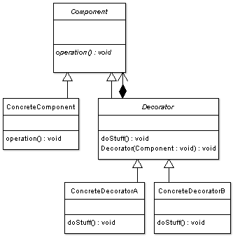

Example:
As an example, consider a window in a windowing system. To allow scrolling of the window's contents, we may wish to add horizontal or vertical scrollbars to it, as appropriate. Assume windows are represented by instances of the Window class, and assume this class has no functionality for adding scrollbars. We could create a subclass ScrollingWindow that provides them, or we could create a ScrollingWindowDecorator that merely adds this functionality to existing Window objects. At this point, either solution would be fine. (Another solution is to simply modify the existing Window class, but this is not always possible—we might not have access to its implementation, or we might be adding storage overhead for new functionality that the majority of objects will not use.)
Now let's assume we also wish the option to add borders to our windows. Again, our original Window class has no support. The ScrollingWindow subclass now poses a problem, because it has effectively created a new kind of window. If we wish to add border support to all windows, we must create subclasses WindowWithBorder and ScrollingWindowWithBorder. Obviously, this problem gets worse with every new feature to be added. For the decorator solution, we need merely create a new BorderedWindowDecorator—at runtime, we can decorate existing windows with the ScrollingWindowDecorator or the BorderedWindowDecorator or both, as we see fit.

// the Window interface
interface Window {
public void draw(); // draws the Window
public String getDescription(); // returns a description of the Window
}

// implementation of a simple Window without any scrollbars
class SimpleWindow implements Window {
public void draw() {
// draw window
}

public String getDescription() {
return "simple window";
}
}
The following classes contain the decorators for all Window classes, including the decorator classes themselves..
// abstract decorator class - note that it implements Window
abstract class WindowDecorator implements Window {
protected Window decoratedWindow; // the Window being decorated

public WindowDecorator (Window decoratedWindow) {
this.decoratedWindow = decoratedWindow;
}
}

// the first concrete decorator which adds vertical scrollbar functionality
class VerticalScrollBarDecorator extends WindowDecorator {
public VerticalScrollBarDecorator (Window decoratedWindow) {
super(decoratedWindow);
}

public void draw() {
drawVerticalScrollBar();
decoratedWindow.draw();
}

private void drawVerticalScrollBar() {
// draw the vertical scrollbar
}

public String getDescription() {
return decoratedWindow.getDescription() + ", including vertical scrollbars";
}
}

// the second concrete decorator which adds horizontal scrollbar functionality
class HorizontalScrollBarDecorator extends WindowDecorator {
public HorizontalScrollBarDecorator (Window decoratedWindow) {
super(decoratedWindow);
}

public void draw() {
drawHorizontalScrollBar();
decoratedWindow.draw();
}

private void drawHorizontalScrollBar() {
// draw the horizontal scrollbar
}

public String getDescription() {
return decoratedWindow.getDescription() + ", including horizontal scrollbars";
}
}
Here's a test program that creates a Window instance which is fully decorated (i.e., with vertical and horizontal scrollbars), and prints its description:
public class DecoratedWindowTest {
public static void main(String[] args) {
// create a decorated Window with horizontal and vertical scrollbars
Window decoratedWindow = new HorizontalScrollBarDecorator (
new VerticalScrollBarDecorator(new SimpleWindow()));

// print the Window's description
System.out.println(decoratedWindow.getDescription());
}
}

Façade Pattern

A facade is a simpler mask given to a complex entity. A facade pattern is based on the basic principle that all the complexities are to be hidden behind a simpler interface.
A very appropriate example from JDK itself is the JDBC. JDBC is an abstraction over database-access mechanisms. While a developer is not at all exposed to the nitty-gritties of as to how the databse specific driver classes internally connect to and read data from the database.
All that the developer is exposed is the interfaces like Connection, ResultSet, Statement. Their implementation classes hide all the complexities behind this simple interface we know as JDBC and hence is a facade.
Ex:
/** "Façade" */
class UserfriendlyDate
{
Calendar cal = Calendar.getInstance();
SimpleDateFormat sdf = new SimpleDateFormat("yyyy-MM-dd");

public UserfriendlyDate (String isodate_ymd) throws ParseException {
Date date = sdf.parse(isodate_ymd);
cal.setTime(date);
}

public void addDays (int days) {
cal.add (Calendar. DAY_OF_MONTH, days);
}

public String toString() {
return sdf.format(cal.getTime());
}
}

/** "Client" */
class FacadePattern
{
public static void main(String[] args) throws ParseException
{
UserfriendlyDate d = new UserfriendlyDate("1980-08-20");
System.out.println ("Date: " + d);
d.addDays(20);
System.out.println ("20 days after: " + d);
}
}

Flyweight Pattern

The pattern here states about a mechanism by which you can avoid creating a large number of object instances to represent the entire system.

